|  |  |  |
| --- | --- | --- |
|  | **Graded Assignment # 1**  **Semester: SPRING 2023 PHYSICS (PHY101)** | **Total Marks: 30**  **Due Date:**  **16th May, 2023** |

**Objective:**

The assignment has been designed to enhance your knowledge and understanding about Laws of Physics and application of Physics in our daily life.

**Instructions:**

* Please read the following instructions carefully before solving & submitting assignment:
* To solve this assignment, you should have good command over first **10 video lectures**.
* The assignment will not be accepted after due date.
* Zero marks will be awarded to the assignment that does not open or the file is corrupt.
* The assignment file must be an MS word (doc) file format; Assignment will not be accepted in any other format.
* Use Math Type or Equation Editor etc for mathematical symbols.
* Zero marks will be awarded to the assignment if copied (from other student or copied from handouts or internet).
* Don’t wait for the last date to submit your assignment.

**For any query about the assignment, contact only** [phy101@vu.edu.pk](mailto:phy101@vu.edu.pk)

**Do not post queries related to assignment on MDB.**

**Question #1**

Is it true or wrong to say that, a ball will land at the same time if you drop it straight down from the top of a tower or if you throw it out horizontally? Either yes or no explain it with a solid reason. **Marks = 5**

**Question #2**

Calculate the X & Y component of car‘s average velocity, by using the data given in the following figure.  **Marks = 10**

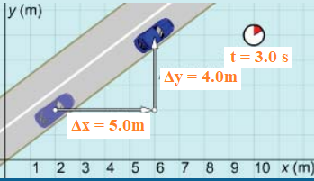

**Question # 3**

A body is moving at 30 km/h. While veering to the right, it keeps moving at the same speed. As there force involved in this case or not. Either yes or no explain it with a solid reason. **Marks = 5**

**Question # 4**

A man is holding a suitcase as shown in the figure. Using the mentioned data in figure calculate the magnitude & direction of suitcase’s acceleration. **Marks = 10**

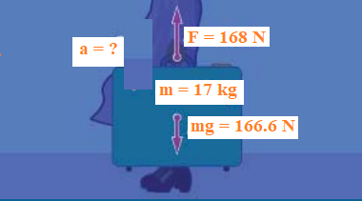

<<<<<<<<<<<<<<<<<<<<, Good Luck>>>>>>>>>>>>>>>>>